TASK 1:
import java.util.Arrays;
public class PortfolioAnalyzer {
public static double[] calculateDailyProfitLoss(double[] openingPrices, double[] closingPrices) {
int numStocks = openingPrices.length;
double[] profitLosses = new double[numStocks];
for (int i = 0; i < numStocks; i++) {
profitLosses[i] = closingPrices[i] - openingPrices[i];
}
return profitLosses;
}
public static void main(String[] args) {
double[] openingPrices = {10.0, 12.5, 8.0, 15.0};
double[] closingPrices = {11.0, 13.0, 7.0, 16.0};
double[] profitLosses = calculateDailyProfitLoss(openingPrices, closingPrices);
System.out.println(Arrays.toString(profitLosses));
}
}

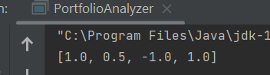
TASK 2:
import java.util.ArrayList;
public class DuplicateRemover {
public static ArrayList<Integer> removeDuplicates(ArrayList<Integer> list) {
ArrayList<Integer> distinctList = new ArrayList<>();
for (Integer element : list) {
if (!distinctList.contains(element)) {
distinctList.add(element);
}
}
return distinctList;
}
public static void main(String[] args) {
ArrayList<Integer> list = new ArrayList<>();
list.add(1);
list.add(2);
list.add(3);
list.add(1);
list.add(4);
list.add(2);
list.add(5);
ArrayList<Integer> distinctList = DuplicateRemover.removeDuplicates(list);
System.out.println(distinctList);
}
}

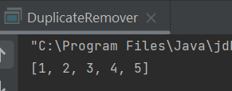
TASK 3:
import java.util.ArrayList;
import java.util.Scanner;
public class Main {
public static boolean isPrime(int num) {
if (num <= 1) {
return false;
}
for (int i = 2; i <= Math.sqrt(num); i++) {
if (num % i == 0) {
return false;
}
}
return true;
}
public static void main(String[] args) {
ArrayList<Integer> numList = new ArrayList<>();
Scanner scanner = new Scanner(System.in);
System.out.println("Please enter 5 numbers:");
for (int i = 0; i < 5; i++) {
int num = scanner.nextInt();
numList.add(num);
}
boolean hasPrime = false;
for (int num : numList) {
if (isPrime(num)) {
hasPrime = true;
break;
}
}
int sum = 0;
if (hasPrime) {
for (int i = 0; i < numList.size(); i += 2) {
sum += numList.get(i);
}
System.out.println("The list has prime numbers.");
} else {
for (int i = 1; i < numList.size(); i += 2) {
sum += numList.get(i);
}
System.out.println("The list does not have prime numbers.");
}
System.out.println("The sum is: " + sum);
}
}

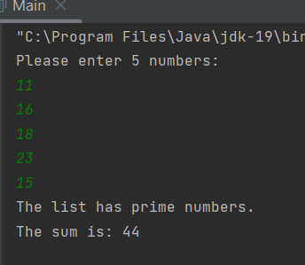
TASK 4:
public class Student {
String name;
Integer rollN;
static String uniName;
static Integer counter =0;
public Integer setRollN(Integer rollN) {
this.rollN = rollN;
counter ++;
return counter;
}
Student(String Name, Integer rollno){
this.name = Name;
this.rollN = setRollN(rollno);
}
static void change(String college){
uniName=college;
}
void display(){
System.out.println("STUDENTS INFORMATION:\n");
System.out.println("Name:" + name);
System.out.println("Roll Number: " + rollN);
System.out.println("University: " + uniName);
}
public static void main(String[] args) {
Student s1 = new Student("Arham",4080);
Student s2 = new Student("John",8875);
Student s3 = new Student("Aarib",4004);
change("FAST University");
s1.display();
s2.display();
s3.display();
}
}

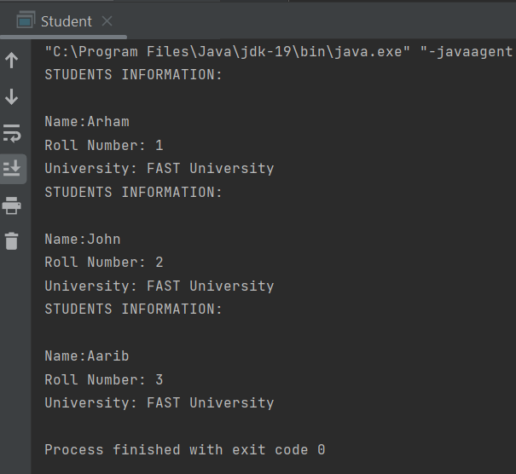

TASK 5:
public class Car {
String make,model;
int year;
double pricePerDay;
public Car(String make, String model, int year, double pricePerDay) {
this.make = make;
this.model = model;
this.year = year;
this.pricePerDay = pricePerDay;
}
public double getPricePerDay() {
return pricePerDay;
}
public static void main(String[] args) {
Car c1 = new Car("Audi","E-tron",2022,11500.0);
Rental.rentCar(c1,24);
System.out.println("Total Revenue: " + Rental.totalRevenue);
}
}
class Rental{
static int numRentals = 0;
static double totalRevenue = 0;
static void rentCar(Car C1, Integer days){
numRentals++;
double rentalPrice = C1.pricePerDay * days;
totalRevenue += rentalPrice;
}
}

OUTPUT:
